Polyphased karst systems in sandstones and quartzites of Minas Gerais, Brazil

Luc Willems¹, Joël Rodet², André Pouclet³, Sergio Melo, Maria Jacqueline Rodet⁴, Augusto S. Auler⁵

¹ EuReKarst, Laboratory of Sedimentology, Dept. of Geology, B20, University of Liege, 4000 Liege, Belgium, ² EuReKarst, UMR 6143 CNRS, Continental and Coastal Morphodynamics, Laboratory of Geology, University of Rouen, 76821 Mont Saint Aignan Cedex, France, ³ EuReKarst, ISTO, Earth Sciences Institute, University of Orleans, France, ⁴ PhD student in Archaeology, University of Paris-X, CNPq grant holder, France, ⁵ CPMTC – Instituto de Geociências, Universidade Federal de Minas Gerais, Belo Horizonte, Brazil,

Abstract:
The state of Minas Gerais (Brazil) exhibits several major karst areas located in sandstone and quartzite terrains, that display a complex suite of underground and surface karstic forms. In the Espinhaço Ridge, central Minas Gerais, several caves, up to a few hundred metres long, occur in the surroundings of the town of Diamantina. Some of these caves, such as Salitre, represent swallow-holes and show dome pits. Other horizontal caves are characterized by corrosion forms generated into the phreatic zone. In some places, such as in the Rio Preto area, these phreatic forms have been overprinted by ceiling tubes, suggesting a polyphase karst evolution, prior to the draining of the cave. Relicts of passages, with circular cross section up to a metre in diametre, can be found amidst the residual tower-like surface landforms, which constitute a typical scenery in the landscape. Their dissection is due to a generalised karstification in the area, resulting in closed canyons, megakarrens and kamenitzas. In southern Minas Gerais, close to the Mantiqueira Ridge, the caves of the state park of Ibitipoca can extent 2 km in length. These caves are associated with a very large hanging geological syncline. Several of these caves contain active streams, that flow for hundreds of metres before disappearing in sand-choked passages. Keyhole cross sections characterize steeply descending passages in these caves, indicating a change from slow phreatic flow towards a faster vadose flow responsible for the vertical incision of the passage. Such change is probably related to base level lowering and/or to turn in the direction of the water flow. Several generations of wall-pockets, from a few centimetres to over a metre long, occur into the caves. These features are good indicators of the initial phase of speleogenesis, generating the initial conduits by their coalescence. This mechanism is also responsible for cut-off meanders. The main river in the area, which flows along the syncline axis, cuts through a rock barrier, generating a tunnel-like passage. This cave drains, through resurgences in its walls, part of the water that flows in other caves located in the flank of the syncline. The non-carbonate karst features observed in the state of Minas Gerais demonstrate the complex organisation of polyphase karst systems due to the linkage of underground and surface forms not previously connected. As in carbonate areas, these systems may play an important hydrological role.
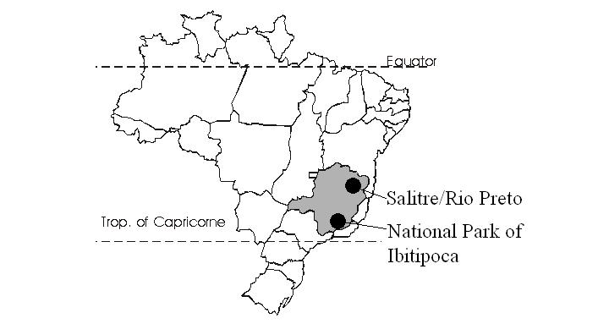
Fig. 1: Localisation of the studied areas

Introduction

Many areas of the Minas Gerais State (Brazil) exhibit a lot of caves developed into sandstones and quartzites. The regions of Serra do Espinhaço and Serra do Ibitipoca allow the study of complex karst systems, which broadly influence the landscapes (Fig. 1).

1. Serra do Espinhaço

The Serra do Espinhaço is a meridian trending mountain range system, that extends to the South of Minas Gerais State up to the Bahia’s State, to the North. We have studied two areas, one near the city of Diamantina, with the cave of Salitre, and another one in the high valley of the Rio Preto. The geology of theses areas consist of Mesoproterozoïc quartzitic sandstones of the Sopa-Brumadinho Formation (Genhser and Mehl, 1977 ; Brichta et al., 1980) with metapelites and metabasites intercalations. The Espinhaço’s Formations were moderately folded, metamorphosed and thrust westward above the margin of the São Francisco craton.

1.1- Cave of Salitre

The cave of Salitre develops in the axial part of a small meridian trending brachy-anticline (Genhser and Mehl, 1977 ; Brichta et al., 1980), about ten kilometres east of the city of Diamantina. All the surface of these area shows numerous lapiaz and tsingy deeper than several meters. Parallel to the anticline axis, a small canyon, averaging 4 to 10 meters wide for 100 meters long, runs into a cirque, about 50 metres in diameter, with vertical walls hollowed by decimetric to plurimetric alveoli (Figs 2-3).
The cave is opened out in the south-west side of the cirque. Its main entrance is a porch, 65 meters wide for 5 meters height, located few meters above the foot of the cliff. The cave goes on 40 meters inside the rock massif and forms a lowered room with a moderate slope following the stratification. The ground is cluttered up with plurimetric collapsed blocks from the roof. These blocks are coated with abundant niter and subordinate variscite. Niter is collected by the local inhabitants that gave the name “salitre” (= niter) to the cave.
A narrow corridor with a ceiling channel extends at the bottom of this room. It opens on wide passages with lower height (averaging 1 metre). Parallel to the anticline axis, a vertical fracture cross the roof and allows the infiltration of water, that moistens all the ceiling and caused chemical precipitation of fine deposits. In the western and lower part of the cave, the slope of different passages increases, in following the dipping stratification of the rock beds (10° to 20°). Numerous ceiling bells and ceiling channels can be observed. A second entrance of the cave is situated in the western cliff foot, 15 metres below the first entrance. The ceiling of these part of the cave is made by a talus-fan with plurimetric collapsed blocks. A water flow disappears inside small fractures at the bottom of the cave, that is located 27 meters below the entrance. The water comes from a closed valley ending at the canyon that leads to the cirque and to the cave. According to the local inhabitants, the water reappears some hundred metres farther, at the riverside of the rio Jaquitinhonha. Almost all the ceiling and a large part of the cave’s walls are coated with a red to dark substance mainly made with Mn, K and Fe. The most important impregnation locates at the axial fracture zone or the ceiling. X-ray diffraction analysis allows to determine cryptomelane and pyrolusite. This coating preserves the initial forms like ceiling bells (Fig. 4), alveoli or ceiling channel developed in a crumbly lithology. Millimetric to centimetric pop-corn speleothems of pop-corn type are found in numerous places of the steep passages.

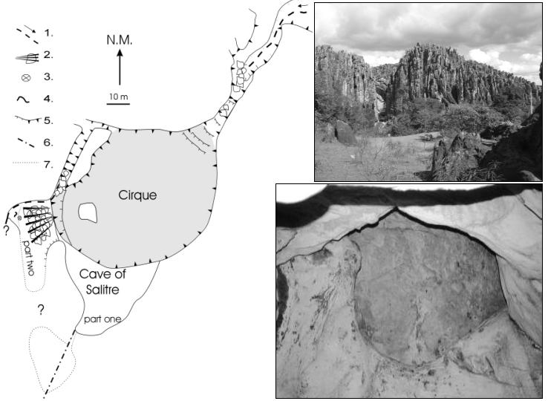

Fig. 2 : Plan of the site of Salitre. 1: flow; 2: fan-talus; 3 ceiling dome; 4: ceiling channel; 5: talus/cliff foot; 6: fracturing; 7: Non surveyed zones. Fig. 3: General view of the Salitre block with the entrance of canyon and lapiaz (B. Laignel, 2004). Fig. 4: Ceiling bell in the cave of Salitre, part two. The dark grey parts are remains of coating (L. Willems, 2003).

According to Genhser and Mehl (1977), the canyon and the cirque where is the cave outlet, could be the rest of a more important cave that collapsed.

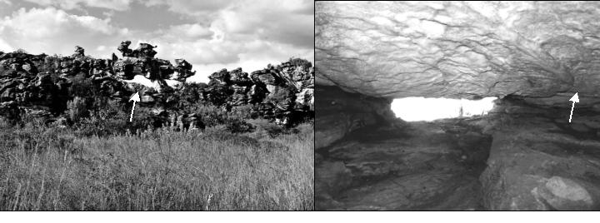

Fig. 5: Example of tower-like relief with lapiaz and relicts of sbuhorizontal passages (white arrow). In the foreground, part of the flat surface, several kilometres long for some hundred metres wide, located in mid-side of the Rio right bank. (L. Willems, 2003). Fig. 6: Ceiling with characteristic corrosion forms cut by a ceiling channel (white arrow). The cave (10 m long) connects two canyons (L. Wllems, 2003).

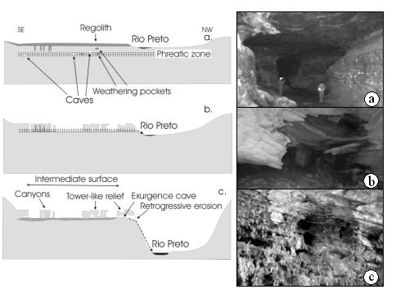
Fig.7 : Genetic hypothesis of the karst system of Rio Preto.
Figs 8:a: Gruta dos Fugitivos (National Park of Ibitipoca, J. Rodet, 2003). b: Gruta dos Moreira (National Park of Ibitipoca). Collapsing of quartzitic strata (L. Willems). c: Caverna_Ponte de Pedra (National Park of Ibitipoca) Alveoli developed on the walls of the cave-tunnel, in the right bank of the Rio do Salto (L. Willems, 2003)

1.2 Karsts of Rio Preto

The high valley of Rio Preto is 50 km to the northeast of the city of Diamantina. Upstream of a water fall caused by a geological dam of gently folded quartzitic strata, the valley widens out for some hundreds of metres. At the edges of this flat area (intermediate surface) (Fig. 7c) , the valley flanks exhibit numerous karstic-related works: inselbergs, closed canyons, tens meters long for more then 10 meters deep and tower-like reliefs (Fig. 5) grooved by lapiaz and megalapiaz. Suhorizontal caves, relicts of passages with circular cross section and canyon-caves are opened in the steep edges of the valley. Orientation of the canyons is controlled by the north-south vertical fracturing associated with the regional strike-slip faults.
The walls of the closed canyons show decimetric to metric alveoli. They are attributed to pedogenetic process and look like basal notches found in numerous carbonated or not-carbonated rocks, as well as alveoli that developed at the contact with endokarstic fillings. Tower-like reliefs are generated by surface weathering, partly due to organic acids produced by mosses and lichens which widely cover the rock surface. Some canyons and tower-like reliefs crosscut many horizontal caves. One of them connects two canyons and has a ceiling with characteristic corrosion forms that were generated into a ground water zone. By places, rests of ceiling channels cut the previous corrosion shapes (Fig. 6). They support the opening of a karst system with increasing of the drainage. Rests of circular passages cross throughout tower-like reliefs. They give evidence of the former direction of drainage. The different reported galleries are essentially developed in following the subhorizontal stratification.
A particular large cave (more than 100 meters of development) in process of dismantling is observed. It cross throughout a tower-like inselberg located between the flat bank of the upper valley and the lower bed of the river. Outlet lateral circular conduits and vertical dissolution columns are evidenced. Further more, the floor of the cave is locally overdug to give canyons that reech the river, several metres deeper
The altitude of the upper flat bank and of the different cavities is quite similar. The cavities seem to be the relict of a karst system at a former phreatic water table level (Fig. 7). Surface erosion has dismantled this system that appeared outside and became a kind of polje. The embayment of the Rio isolates the flat surface. The water drained from this level cross throughout the caves towards the river. Due to the sinking of the river valley, regressive erosion generates canyons inside the caves.
The different forms observed in the high valley of Rio Preto attest the genesis of a complex karst system, that resulted from the connecting of an endokarst with an exokarst.

1. 2.1 Serra de Ibitipoca

The Sierra of Ibitipoca is a natural barrier between the states of Minas Gerais, São Paulo and Rio de Janeiro (Fig. 1). It’s a large synclinal ridge upstanding several hundreds meters higher than the surrounding areas. The lithological composition of the Sierra consists of Meso-Proterozoic quartzites. Dozens of caves are reported in this area and some are among the biggest in the world, for this type of rock (e.g. Gruta das Bromélias, 2750 m of development) (Figs. 8a,b).

2.1- Ponte de Pedra e affluentes (Gruta dos Coelhos, Gruta das Casas)

The cave of Ponte de Pedra is a tunnel about 50 metres long, for 10 metres wide and 12 metres high. It is developed in the west flank of the syncline, parallel to the fold axis. It allows the passage of Rio do Salto throughout the rock barrier. The cave has a keyhole cross section formed by a late vertical erosion due to a lowering of a regional or local base level.
Several generations of centimetric to plurimetric alveoli are developed on the walls of the tunnel, in the right bank of the Rio (Fig. 8c). Some of them are larger and show complex shapes resulted from the coalescence of smaller alveoli. They can be overprinted or dismantled by other alveoli. By places, water outpoured from drains parallel to the dip of strata. They would come from several caves developed higher in the flank of the syncline, where subterranean draining is observed (Gruta dos Coelhos, Gruta das Casas). All alveoli are situated over the notch of late vertical erosion of the tunnel. None of them is observed in the wall of the Rio left bank.
Various alveoli are interpreted as rests of primary endokarsts which have organized the first drain system by their coalescence (Fig. 9). They allowed the underground cut-off of Rio do Salto. Then, the digging of the tunnel increased. This caused a more pronounced erosion on the left bank, according to the dipping disposition of the strata. Primary alveoli are completely erased on this wall, while in the right bank, abandoned by the drainage, they are preserved. Current resurgences, along the west wall of the tunnel provoke a modification of forms by piping.

1.2.2-The drainage of Rio Vermelho (Grutas dos Moreiras, dos Três Arcos, dos Fugitivos).

The drainage of the Serra presents an organization in two directions. The first (Rio do Salto) follows the axis and the pitching of the syncline towards the southwest. The second develops in an opposite direction to the structure, to the northeast (Rio Vermelho). In the cavities of this northeast zone, the sinking of Rio Vermelho corresponds to the development of keyhole cross sections of drains parallel with this last direction. They give evidence of a general change of drainages initially towards Rio do Salto for the benefit of the river basin of Rio Vermelho.

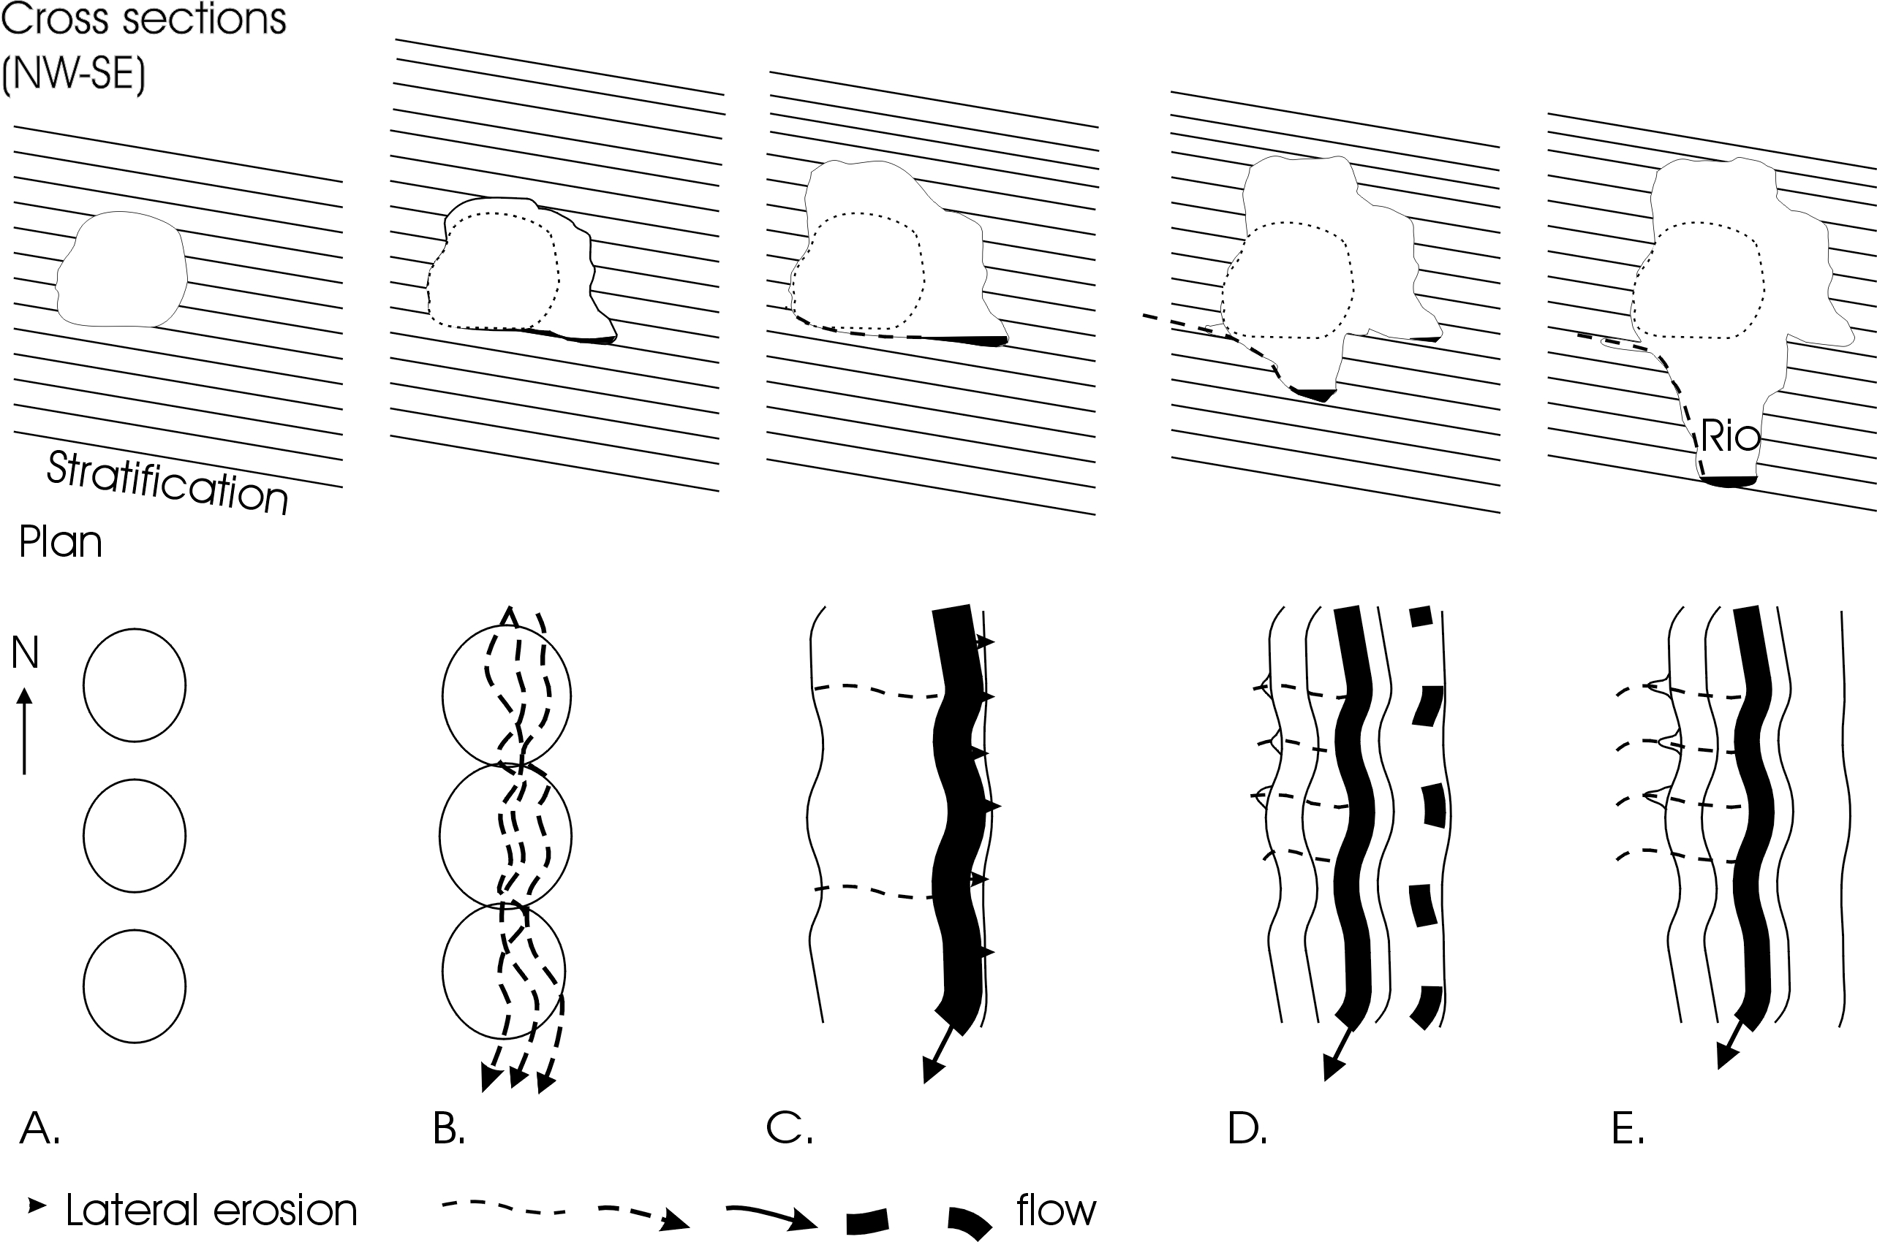

Fig. 9: genetic hypothesis of the Caverna Ponte de Pedra (see text for explanations).

1.2.3 - Discussion

Numerous caves examined in the Ibitipoca Park presents walls or ceilings in process of dislocation (Fig. 8b). Quartzite disintegration produces abundant sandy material, that is evacuated downstream by underground rivers. If the current evolution of cavities mainly resulted from mechanical erosion, initially (bio)chemical process had to prevail in the genesis of caves. Indeed, several subterranean drainages disappear in impenetrable cracks within the block. Yet, only the chemical erosion allows to explain that the volumes of residual sands did not seal large part these caves and did not inhibit their development. Indeed, no downstream resurgence allows a mechanical evacuation of these residues.
The chemical erosion is at the origin of cavities and it implies a weathering dissolution both of the quartz grains and of the siliceous cement such as observed by Chalcraft and Pye (1984) in the tepuys of Venezuela. The aeration of systems causes a change to a incomplete dissolution (Wiegand, J et al., 2004) associated with a mechanical erosion. Bio-physico-chemical conditions currently observed in the visited cavities must to differ from the initial environment in which were generated Ibitipoca's various caves.

The study of the various caves shows that:
-they are generated by general quartzite dissolution according to karstic process that have to be more precisely determined;
-they result from several genetic phases and of adaptation;
-they are the witnesses of the former phases of the regional hydrogeomorphological evolution.

Conclusion

The process of forming and development of cavities in sandstones and quartzites of Minas Gerais are due to the dissolution of siliceous cement and/or quartz grains. The important development of caves, swallow hole, underground rivers, lapiaz, sinkholes and poljes set up complete karst systems. Genetic processes are identical to those of carbonate rocks. Thus, it is a question of karsts in sandstones and quartzites.

Acknowledgements

The authors thank Benoit Laignel and Nicolas Massei for their help in the realization of the fieldwork investigation.

Bibliography

Auler A.S., 2003. Quartzite caves of South America. Encyclopedia of caves and karst science, John Gunn (ed.), Fritzroy Dearborn: 611-613.
Chalcraft, D. & Pye, K., 1984. Humid tropical weathering of Quartzite in southeastern Venezuela. Z. Geomorph. N.F., Berlin-Stuttgart, 28, 3, pp. 321-332.
Brichta, A., Paternoster, K., Schöll, W.U., Turuinsky, F., 1980. Die Gruta do Salitre bei Diamantina, Minas Gerais, Basilien, kein „Einstursloch“. Z. Geomorph. N.F., 24-2, 236-242, Berlin – Stuttgart.
Corrêa Neto A.V., 2000. Speleogenesis in quartzite in Southeastern Minas Gerais, Brazil. Speleogenesis – evolution of karst aquifers, National Speleological Society: 452-457.
Genser, H, Mehl, J., 1977. Einsturzlöcher in silikatischen Gesteinen Venezuelas und Brasiliens. Z. Geomorph. N.F., 21, 4: 431-434, Berlin, Stuttgart.
Martini J.E.J., 2000. Quartzite caves in Southern Africa. Speleogenesis – evolution of karst aquifers, National Speleological Society: 458-461.
Martini J.E.J., 2003. Silicate karst. Encyclopedia of caves and karst science, John Gunn (ed.), Fritzroy Dearborn: 649-653.
Melo da Silva S., 2004. Carstificação em rochas siliciclásticas. Estudo de caso na Serra do Ibitipoca, Minas Gerais. Universidade Federal de Minas Geraïs, Inst. Geociëncias, 157 p.
Wiegand, J; Fey, M; Haus, N; Karmann, I. 2004. Geochimische und hydrochimische untersuchung zur genese von sandstei-und quartzitkarst in der Chapada Diamantina und im eiserne viereck (Brasilien). Z. dt. geol. Ges. 155: 61-90.
Willems L., 2000. Phénomènes karstiques en roches silicatées non carbonatées. Cas des grès, des micaschistes, des gneiss et des granites en Afrique sahélienne et équatoriale. Thèse de doctorat, 257 p., 145 figs., 137 photos, Université de Liège, Belgique.
Willems L., Rodet J., Auler A.S., Piló L.B., Pouclet A., 2003a. Karsts en roches non carbonatées - l'exemple des quartzites et des itabirites de Minas Gerais (Brésil). "Le karst de la craie en Normandie", J. Rodet (dir.), Journées de l'AFK 2003, Rouen, 10-12 septembre 2003, poster, colloque et excursions : 31.
Willems L., Auler A., Rodet J, Melo da Silva S., Pouclet A., 2003b. Karsts en roches non carbonatées dans l'état de Minas Gerais - Brésil : résultats préliminaires. Journées 2003 de Spéléologie Scientifique, Centre Belge d'Etudes Karstologiques, groupe de contact du F.N.R.S., et la Commission Scientifique de l'Union Belge de Spéléologie, Han sur Lesse, 15-16 novembre 2003, résumé : 1 p.
Willems L., Rodet J., Auler A.S., Pouclet A., 2004a. Reflexões sobre a gênese do carste. Exemplos em diferentes litologias: Brasil, Niger, Camarões, França e Holanda. Carste-2004, Belo Horizonte, 27-31 juillet 2004, Caderno de Resumos: 85, poster.
Willems L., Rodet J., Pouclet A., Rodet M.J., Hatert F., Compère P., Auler A.S., 2004b. Carste no quartzito: Gruta do Salitre (Diamantina, Minas Gerais, Brasil). Carste-2004, Belo Horizonte, 27-31 juillet 2004, Cadernos de Resumos: 86, poster.
Willems L., Rodet J., Pouclet A., Rodet M.J., Hatert F., Compère P., Auler A.S., 2004c. Carste no quartzito: o Parque Estadual do Rio Preto (São Gonçalo do Rio Preto, Minas Gerais, Brasil). Carste-2004, Belo Horizonte, 27-31 juillet 2004, Caderno de Resumos: 86, poster.
Willems L., Rodet J., Auler A., Piló L.B., Pouclet A., 2004d. Karsts en roches non carbonatées – l’exemple des quartzites et des itabirites de Minas Gerais, Brésil – Karsts in non carbonated rocks – examples in quartzite and itabirite rocks from Minas Gerais, Brazil. Actes des Journées Européennes de l’AFK 2003, Rouen, J. Rodet (ed.), novembre 2004 : 74-75.

